Codes:

import pandas as pd

import numpy as np

import matplotlib.pyplot as plt

%matplotlib inline

import seaborn as sns

import time

from sklearn.metrics import classification_report

from sklearn.metrics import confusion_matrix

from nltk.tokenize import RegexpTokenizer

from nltk.stem.snowball import SnowballStemmer

from sklearn.feature_extraction.text import CountVectorizer

from sklearn.pipeline import make_pipeline

import joblib

# Loading the dataset

df= pd.read_csv("dataset_phishing.csv")

df.head()

df.info()

df.describe()

df.shape

df.isnull().sum()

plt.figure(figsize=(5, 5)) # Adjust the figure size if needed

status_counts = df['status'].value_counts()

colors = ['skyblue', 'lightcoral']

explode = (0.5, 0)

plt.pie(status_counts, labels=status_counts.index, autopct='%1.1f%%', startangle=90, wedgeprops=dict(width=0.4), explode=explode, colors=colors)

plt.title("Distribution of Status")

# Add legend

plt.legend(status_counts.index, loc="best")

plt.show()

# checking unique values and counts from the collected object features

df['status'].value_counts()

tokenizer = RegexpTokenizer(r'[A-Za-z]+')

tokenizer.tokenize(df.url[0]) # this will fetch all the words from the first URL

# Tokenizing all the rows

print('Getting words tokenized ...')

t0= time.perf_counter()

df['text_tokenized'] = df.url.map(lambda t: tokenizer.tokenize(t))

t1 = time.perf_counter() - t0

print('Time taken',t1 ,'sec')

stemmer = SnowballStemmer("english") # choose a language

# Getting all the stemmed words

print('Getting words stemmed ...')

t0= time.perf_counter()

df['text_stemmed'] = df['text_tokenized'].map(lambda l: [stemmer.stem(word) for word in l])

t1= time.perf_counter() - t0

print('Time taken',t1 ,'sec')

# Joining all the stemmmed words.

print('Get joiningwords ...')

t0= time.perf_counter()

df['text_sent'] = df['text_stemmed'].map(lambda l: ' '.join(l))

t1= time.perf_counter() - t0

print('Time taken',t1 ,'sec')

bad_sites = df[df.status == 'phishing']

good_sites = df[df.status == 'legitimate']

cv = CountVectorizer()

feature = cv.fit_transform(df.text_sent) #transform all text which we tokenize and stemed

feature[:5].toarray() # convert sparse matrix into array to print transformed features

joblib.dump(cv, 'count_vectorizer.pkl')

from sklearn.model_selection import train_test_split

trainX, testX, trainY, testY = train_test_split(feature, df.status)

from sklearn.metrics import accuracy_score,confusion_matrix,classification_report

from sklearn.svm import SVC

svm_clf =SVC(C=100, gamma=0.0001, kernel='rbf')

svm_clf.fit(trainX,trainY)

pred=svm_clf.predict(testX)

accuracy_score(pred,testY)

print('Training Accuracy :',svm_clf.score(trainX,trainY))

print('Testing Accuracy :',svm_clf.score(testX,testY))

con_mat = pd.DataFrame(confusion_matrix(svm_clf.predict(testX), testY),

columns = ['Predicted:Bad', 'Predicted:Good'],

index = ['Actual:Bad', 'Actual:Good'])

print('\nCLASSIFICATION REPORT\n')

print(classification_report(svm_clf.predict(testX), testY,

target_names =['Bad','Good']))

print('\nCONFUSION MATRIX')

plt.figure(figsize= (6,4))

sns.heatmap(con_mat, annot = True,fmt='d',cmap="YlGnBu")

from sklearn.ensemble import RandomForestClassifier

forest_clf = RandomForestClassifier(max_depth=10, random_state=0)

forest_clf.fit(trainX,trainY)

ran_pred=forest_clf.predict(testX)

accuracy_score(ran_pred,testY)

print('Training Accuracy :',forest_clf.score(trainX,trainY))

print('Testing Accuracy :',forest_clf.score(testX,testY))

con_mat = pd.DataFrame(confusion_matrix(forest_clf.predict(testX), testY),

columns = ['Predicted:Bad', 'Predicted:Good'],

index = ['Actual:Bad', 'Actual:Good'])

print('\nCLASSIFICATION REPORT\n')

print(classification_report(forest_clf.predict(testX), testY,

target_names =['Bad','Good']))

print('\nCONFUSION MATRIX')

plt.figure(figsize= (6,4))

sns.heatmap(con_mat, annot = True,fmt='d',cmap="YlGnBu")

**Screenshots**

Dataset Sample Values

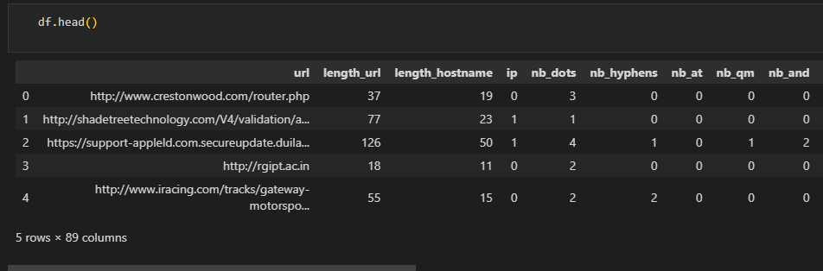

Columns names and Datatypes

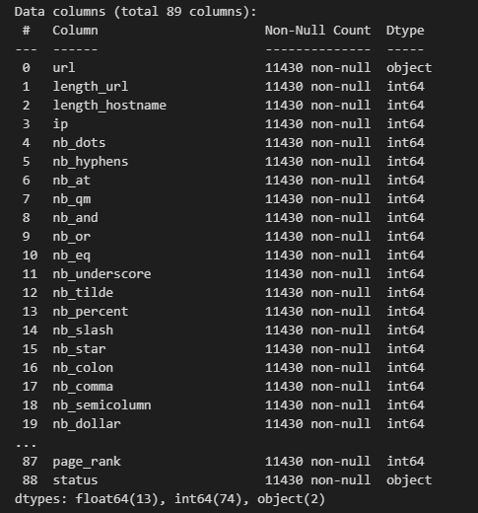

Statistical Analysis 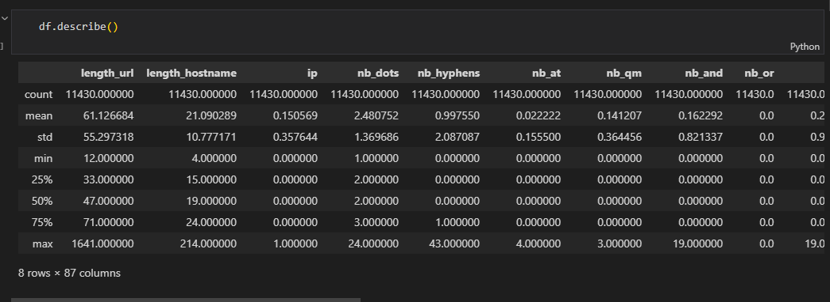

Dataset Rows and Columns

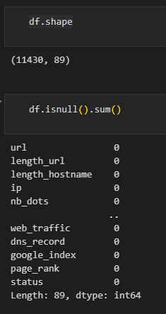

Missing Values Count



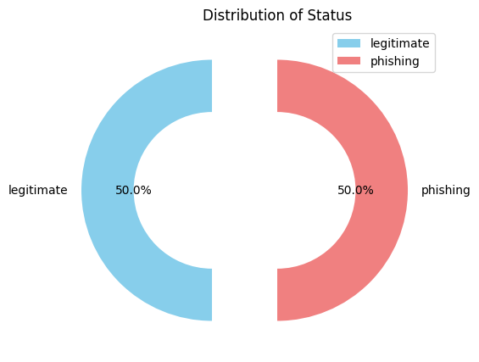

Random Forest

Accuracy and Classification Report

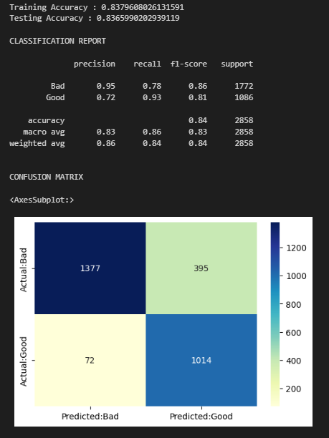

Confusion Matrix



Decision Tree

Accuracy and Classification Report

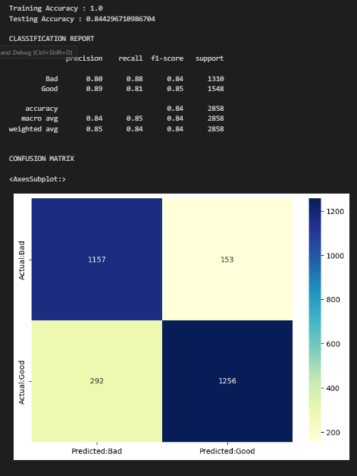

Confusion Matrix



Comparison Chart

